Real Term ASCII Terminal Software
Configuration for 328eForth

Download and install the latest version of RealTerm ASCII terminal software on the computer you wish to use to commutate with the Atmega328P micro-processor running the 328eForth system. The software must be configured to properly access the serial connection through the computers USB port. Using a USB to Serial adapter or a Arduino development board (Arduino Nono) check the Windows Device Manager under Com ports for the com port used by the USB to serial connection.
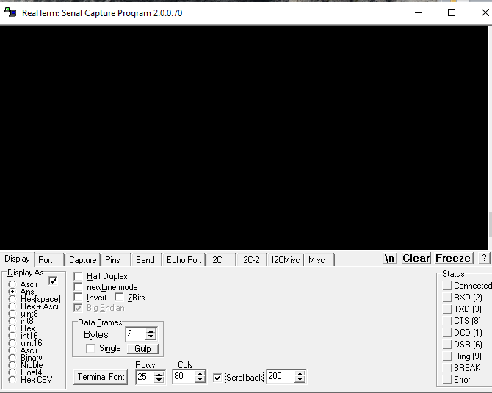
We change Display as to Ansi, set Rows to 25 and check Scrolback to configure the basic settings.

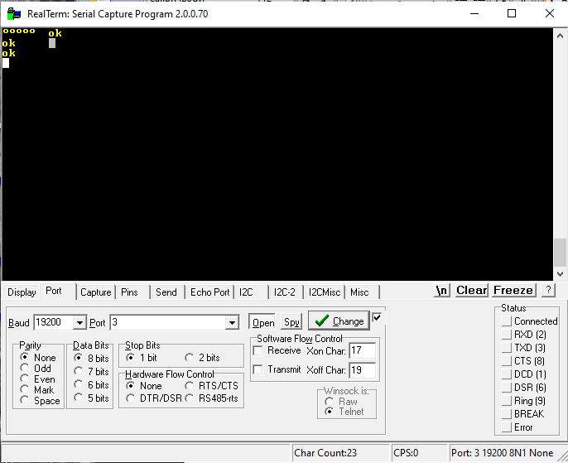
On the Posts Tab, change the Baud rate to 19,200 and make sure the com port number is the one identified with Device Manage. Click the Change button and then test connection by pressing Enter several times. The 328eForth will reply with the “ok” prompt. You can check that the Forth Interpreter is running by typing 3 4 + . Enter and the result of 7 and ok will be output top the terminal screen.

Loading Files for Completion

On the Send Tab in the “Dump Files to Port” text box add the path and file name from you computer of the Forth text file containing the Forth “words” to compile into the Forth words dictionary. Tab to the second Delay box and add 500 for the milliseconds to delay after each line of text is transmitted to the 328eForth system. The system needs time to compile to the Forth dictionary.

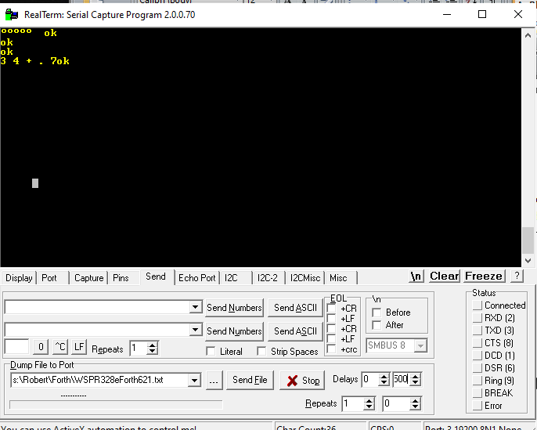

Forth source text files can the be sent to the Compiler for adding to the Forth dictionary,
Caution: Be sure to click Stop when the file is finished.

